Recent NIH BUDGET GROWTH fueling economic growth:
NIH Research Funding Drove Nearly $74 Billion in Economic Activity
and Supported More Than 433,000 Jobs in fy18

New Data Shows Economic Impact of NIH Research Funding in 50 States + DC

WASHINGTON, DC – April 1, 2019 – Data released today by United for Medical Research (UMR) show that increases to the National Institutes of Health (NIH) budget since 2015 have contributed to steady increases in jobs and economic activity over this period.

In fiscal year 2018, NIH research funding directly and indirectly supported 433,011 jobs nationwide. When cycled through the economy, the income generated by these jobs, as well as through the purchase of research-related equipment, services and materials, produced $73.909 billion in new economic activity. This represents an almost 23 percent increase in the number of jobs supported over fiscal year 2015 and a nearly 22 percent increase in economic activity.

“This data is an important reminder that, while medical research takes time to produce results in the form of new therapies and cures, the secondary economic impact of this research is immediate and is experienced in communities in every state in the nation,” said UMR President Alex Currie.

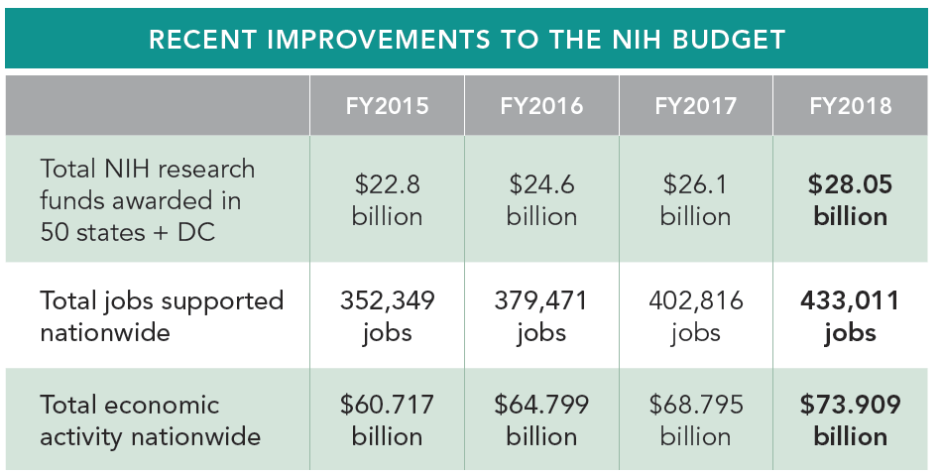

“UMR greatly appreciates the strong bipartisan congressional support that, over the past four years, has worked to put the NIH budget back on a sustainable growth path after years of flat funding. Now, as Congress considers spending decisions for fiscal year 2020, we urge Members to continue this process and provide the NIH an increase of at least $2.5 billion, allowing for real growth above inflation. There is no more powerful investment than one that improves the public’s health, provides hope to patients and families affected by disease and fuels the economy,” Currie said.
In fiscal year 2018, the NIH provided just over $28 billion in extramural research funding to scientists in all 50 states and the District of Columbia. This funding directly supports the jobs of the principal investigators and their research teams, the producers of the specialized equipment used in the research process, and ultimately, the jobs of the people who provide the goods and services demanded by those researchers and equipment manufacturers. According to the analysis, the median state has 4,585 jobs due to NIH research activity with 23 states having employment of 5,000 or more jobs and 13 states having employment of 10,000 or more jobs. Additionally, the income generated by these jobs, as well as through the purchase of research-related equipment, services and materials, when cycled through the economy, produced nearly $74 billion in new economic activity in 2018. Twenty-eight states experienced an economic gain of $500 million or more, with 20 states experiencing a gain of $1 billion or more.

United for Medical Research has provided an analysis of the employment and economic activity attributable to NIH extramural research spending each year since 2011. Each of the analyses has been conducted by Dr. Everett Ehrlich of ESC Company using the Regional Input-Output Modeling System (RIMS II) developed by the Department of Commerce.

Link to UMR report, including 50-state data: HERE
Link to map with state-specific data: HERE

Media Contact:
Sue Garman
sgarman@hudsonlake.com
240-687-2026

United for Medical Research is a coalition of leading scientific research institutions and industries, and patient and health advocates that have joined together to seek steady increases in funding for the National Institutes of Health. Learn more at www.unitedformedicalresearch.com. For examples of the amazing things that NIH research is making possible, visit www.amazingthingspodcast.com.

